Brandywine Hall
709 S. New Street
Built: | Size: 192,156 SF
Acquired: | Condition:
Last Renovation: | Function: Privatized  Residence Hall

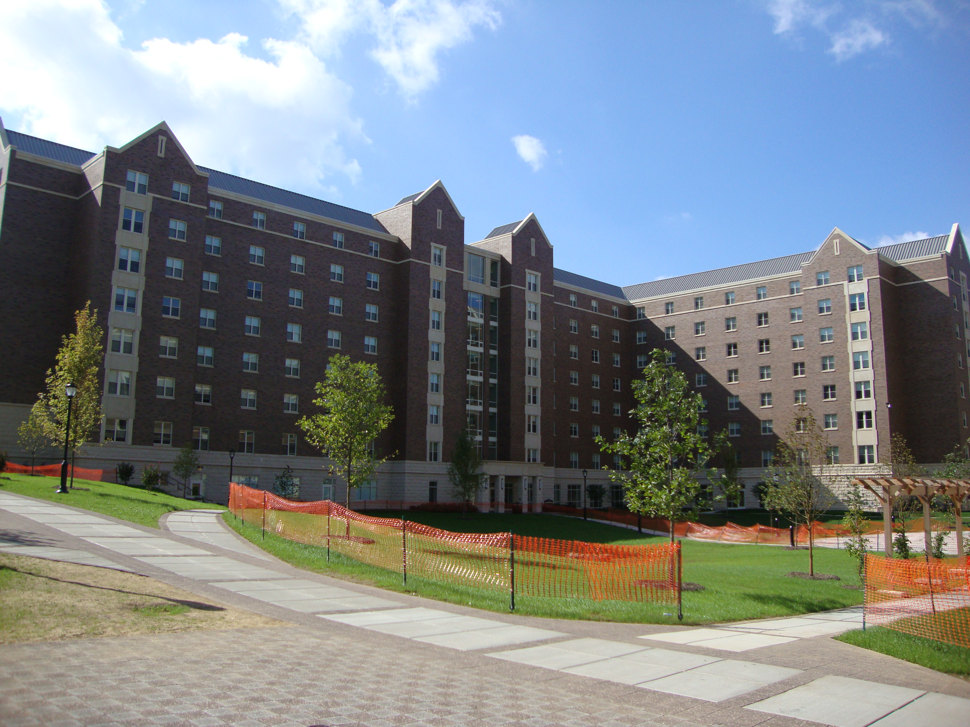

Present Use: Residence Hall

Disability Access:

Past Projects:

Scheduled Projects or Capital Renovations:

Description of Construction:

Condition and Use Assessment:
Deferred Maintenance (2006): $ | Est Replacement Cost (2006): $
Facility Condition Index: 0. | Deficiency/SF: $
Yearly Electric Use Cost: $ | Yearly Water Use Cost $

